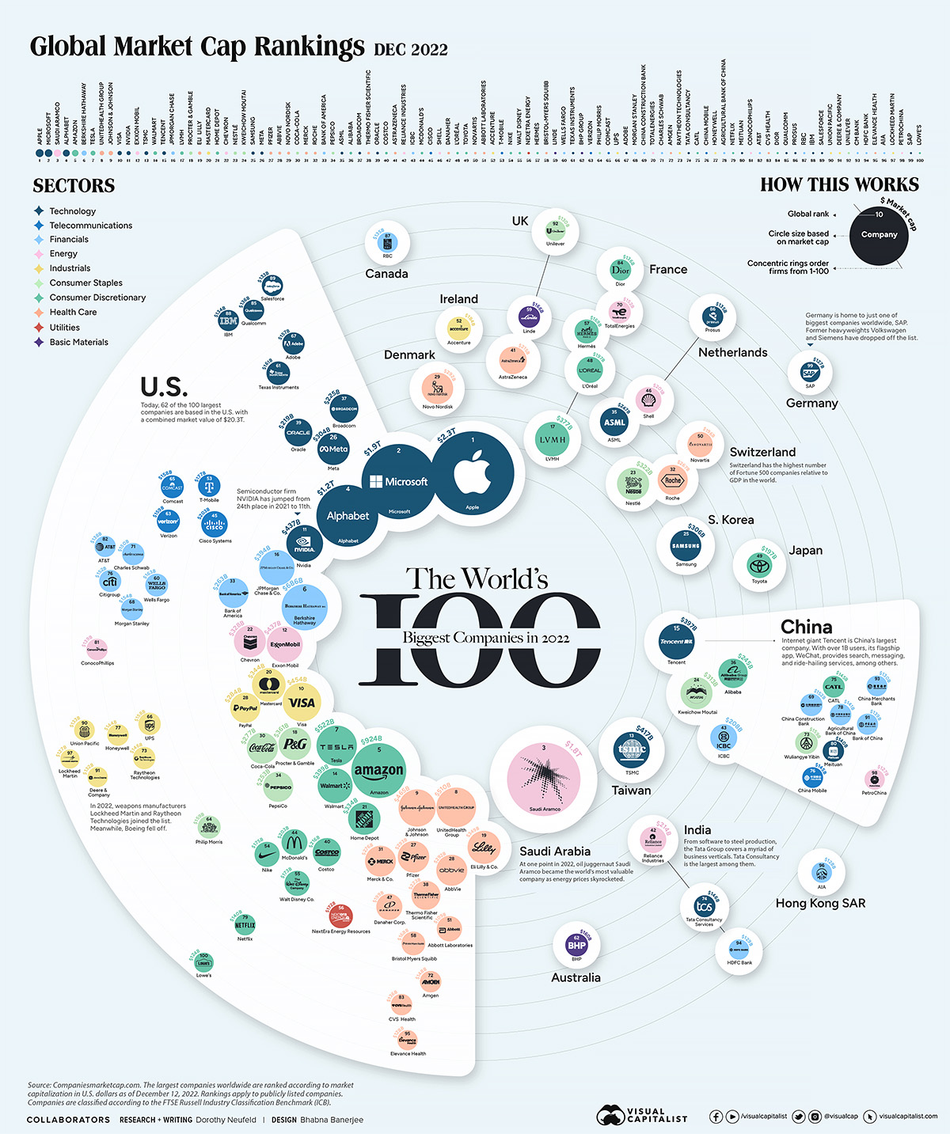

https://www.visualcapitalist.com/biggest-public-companies-in-the-world-2022/

What?

The image illustrates the top 100 biggest companies on December 2022 by their market cap. There are 3 data types could be seen in the image: the company name (e.g. Apple, Microsoft) is a categorical data type which is nominal specifically since it is not ordered; the company market cap value (e.g. Apple has a market cap of $2.3T) is a quantitative data type since the data uses number as the amount of money; the sectors name (e.g. Technology) is a nominal data type. The dataset type for the company name and sector name are table while the company market cap value is field.

Why?

The visualisation is belong to “Visual Capitalist” website and it is free to share according to the author. Thus, The aim of the visualisation could be present the current standings of the top company to the world. Hence this visualisation could be use in the chain Analyse -> Consume -> Present.

How?

Marks:

The company name is represented as a point in the chart and the list at the top of the image.

The company market cap value is represented as an area which belong to the company point.

The sector name is represented as a point with its corresponding sector name.

Channels

The company name uses hue to identify the sector of the company and Shape to represent the icon of the company.

The company market cap value uses area to represent the market value of the company.

The sector name uses hue to identify its sector.